**EE4717/IM4717 Web Application Design - Project Report**

**Design project group number**: F37-DG15

**Team members**: Zhang Linghan (IM4717)

Zhang Guobin(EE4717)

**Project Title**: THE SHOEBOX (Online ecommerce portal selling sports shoes)

**Summary of Project**:

The objective is to build an online ecommerce portal selling sports shoes. The web application allows consumers to view and search for products filtered by their preference, add products to shopping cart and place orders. The products are listed with details including images, brand information and choices of styles, sizes etc.

**Table of Contents**

**1. Application Requirements and Specifications**

**2. Functional Requirements and Specifications**

**3. Design of the web application**

3.1 Site Map

3.2 Storyboard

3.3 Wireframe

*3.3.1 Home Page*

*3.3.2 Product List Page*

*3.3.3 Product Detail Page*

*3.3.4 Shopping Cart Page*

**4. Implementation**

4.1 Coding of the web page template

4.2 Coding of the pages

4.3 Coding of the each function

**5. Testing of web application**

**6. Conclusion**

**Appendices**

Appendix : Source Codes

1. **Application Requirements and Specifications**

The application is an online ecommerce portal. The requirements are listed below. The application should:

1. Allow users to view list of products
2. Allow users to filter the products based their preferences.
3. Enable online purchase of products listed in the shop.
4. Provide contact information.
5. **Functional Requirements and Specifications**
6. **Allow users to view list of products**
   1. There will be pages that lists all the available product for user. The product listed will have a thumbnail picture of the item and description including items name, brand, unit price etc.
7. **Allow users to filter the products based their preferences.** 
   1. There will be filter one the product list page. User can apply different filter options. The product list should show only items that fits the filter criteria.
   2. Filter can be dynamically applied and product list should be updated accordingly. If no filter is applied by user, all products are shown.
8. **Enable online purchase of products listed in the shop.**
   1. There should be a shopping cart page or component. User can add item to shopping cart while shopping.
   2. User should be able to visit shopping cart page to view all previously selected items with a subtotal.
   3. User should be able to update/delete orders in the shopping cart.
   4. User should be able to checkout if the shopping cart is not empty.
9. **Provide contact information.**
   1. The contact information (phone number, email, location) should be displayed on the page. All page footers should hold include all the above contact information plus social media links.

**3. Design of the web application**

**3.1 Site map**

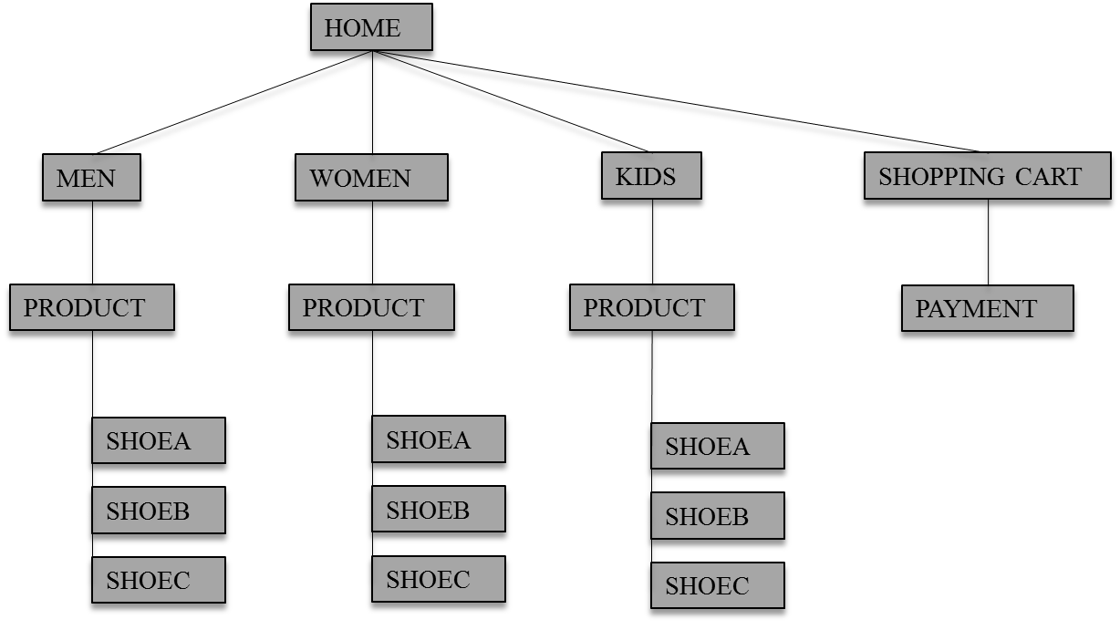

**3.2 Storyboard**

This is the main **home page**. There is a summary of the products. There will be link to different category product list including men, women and kids. iheader

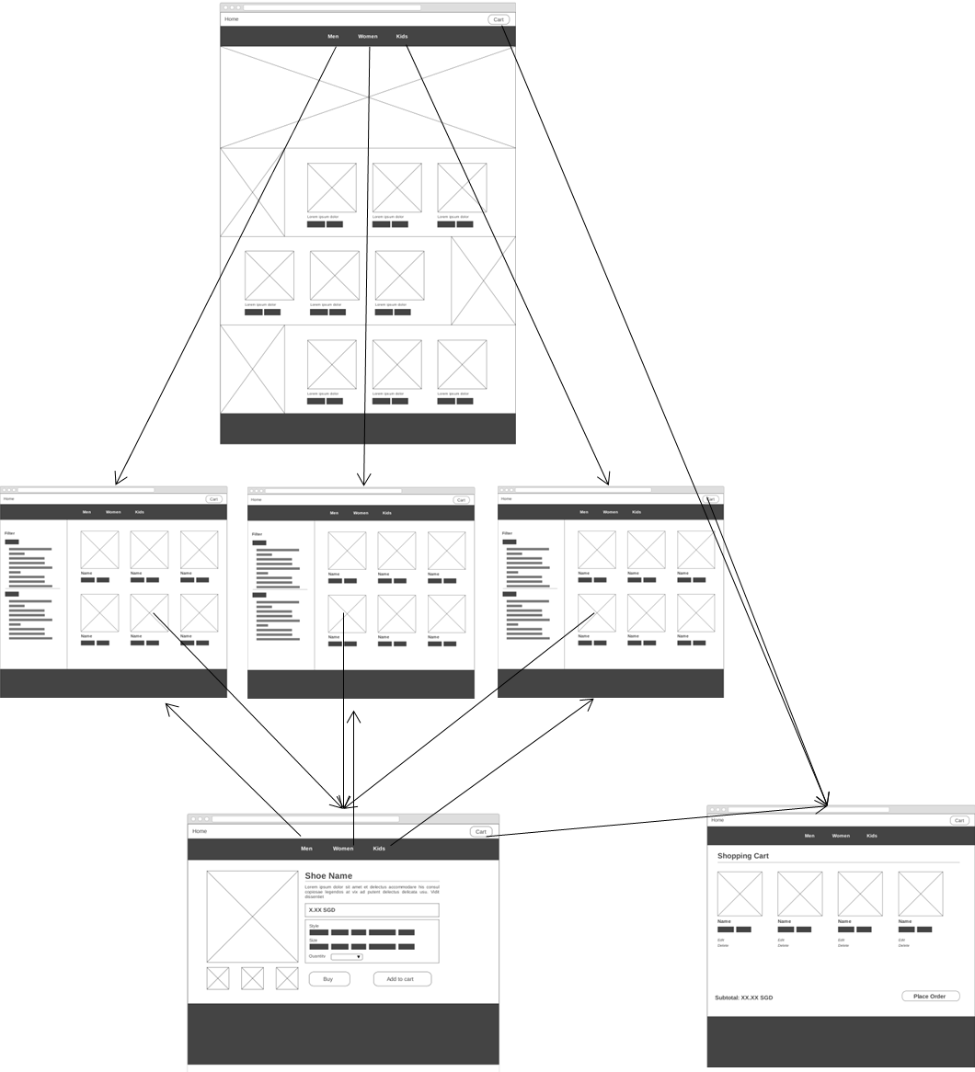

This is the **product list page**. There are more details for the product under each category. Each product links to its matching product formation page.

This is the **product detail page**. All the details for a product were listed inside this page including its name, image, price, description and adding to cart option.

This is the **shopping cart page**. From the shopping cart page, customer can remove/update products in the cart, check out and complete payment easily.

**WOMEN**

**MEN**

**KIDS**

**3.3 Wireframe**

**3.3.1 Home Page**

Page comes with a hero banner slider featuring highlight items, including new arrivals, discounts, feature products. The rest of page lists a summary of 3 main sections (Men, Women, Kids). Featured items for each section is listed for consumer to view.

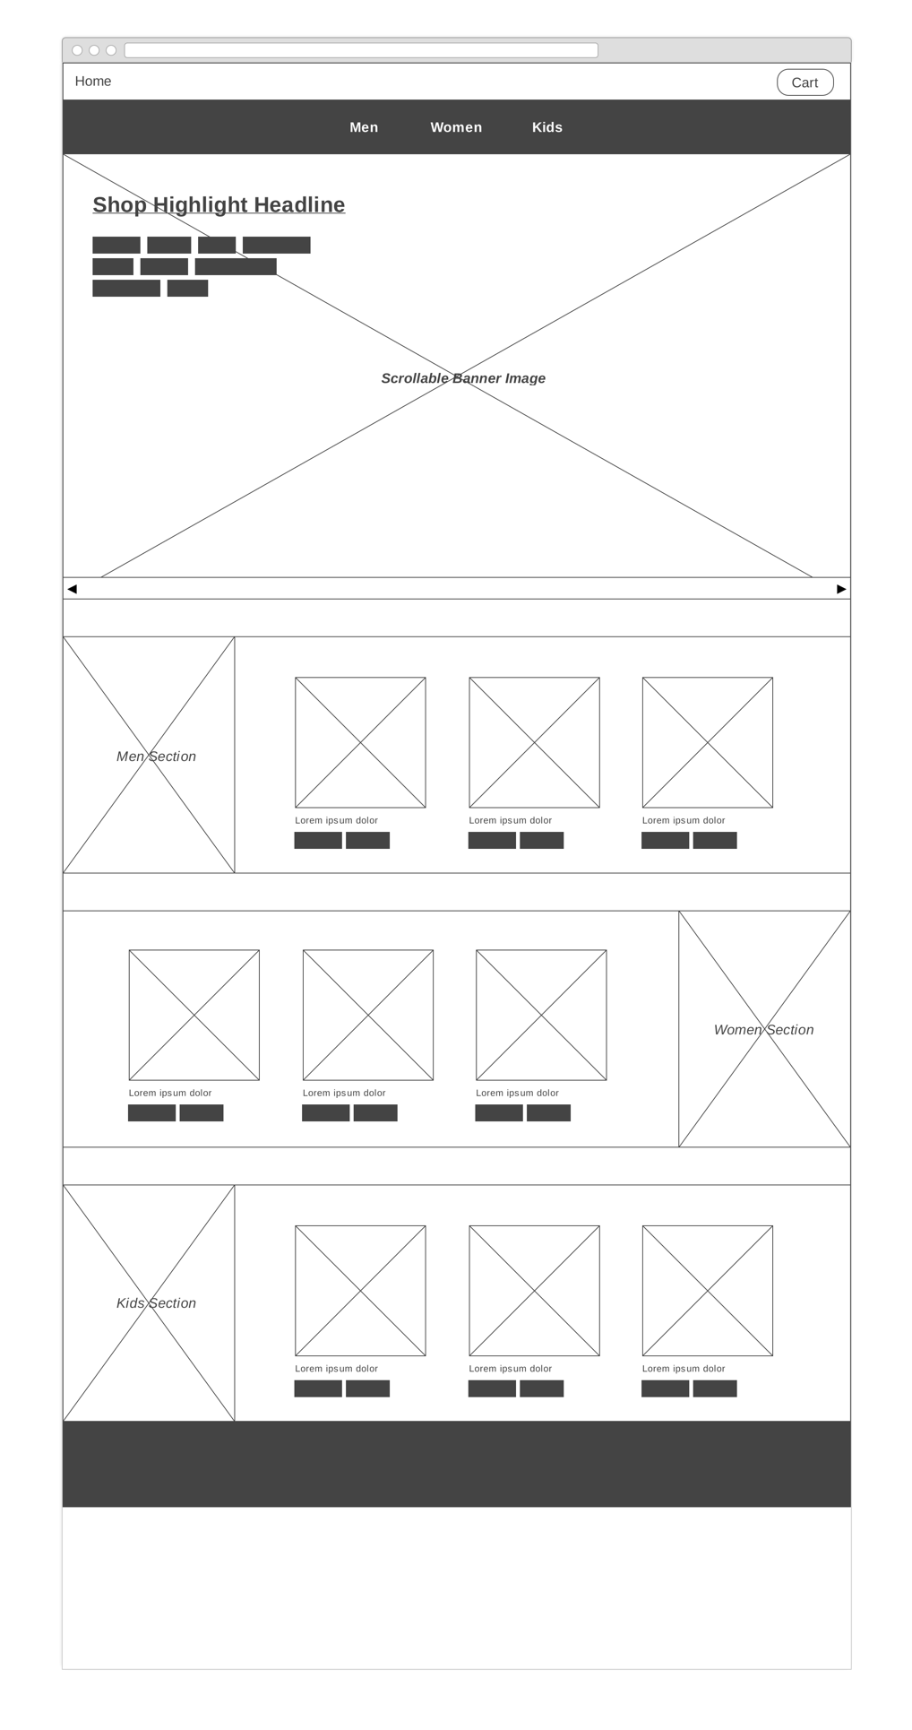

**3.3.2 Product List Page**

Men, women and kids section each has its own product list page with the same layout. The content section follows a tow-column design. Filters with different options are displayed on the left column of the page. On the right column, a scrollable list of product is shown. Based on the filter options, consumers can filter out the preferred product based on brands, colors and etc.

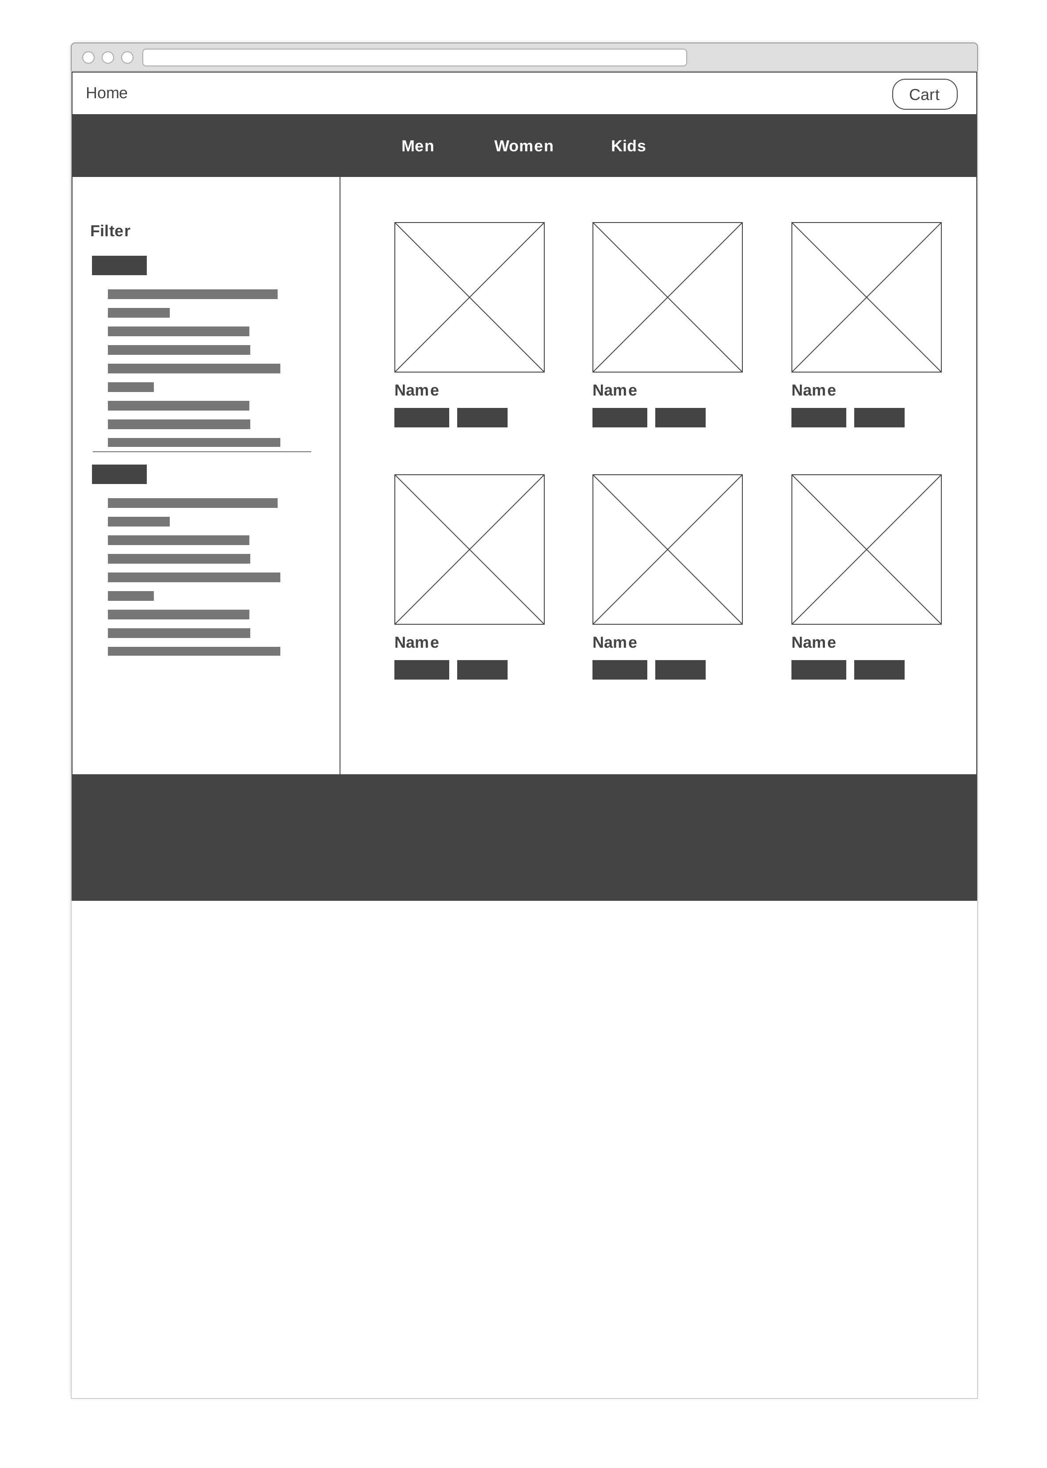

**3.3.3 Product Detail Page**

Product detail page display one single product. User can choose desired quantities, styles, sizes and the order to shopping cart.

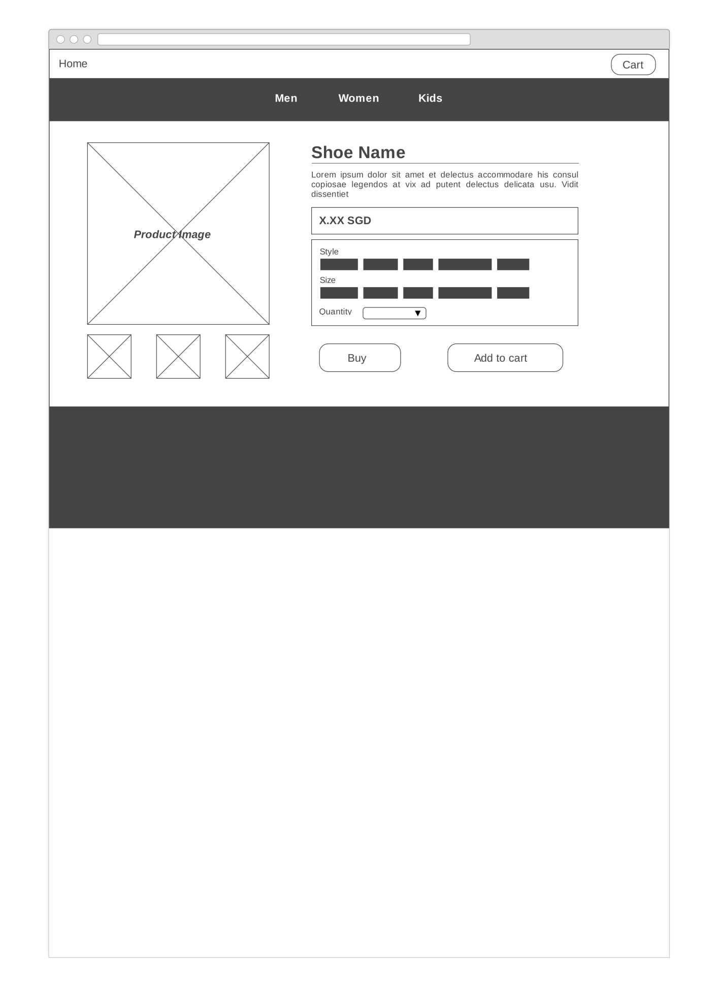

**3.3.4 Shopping Cart Page**

All the chosen products and its related information can be found in shipped cart. From the shopping cart page, customer can remove/update products in the cart, check out and complete payment easily.

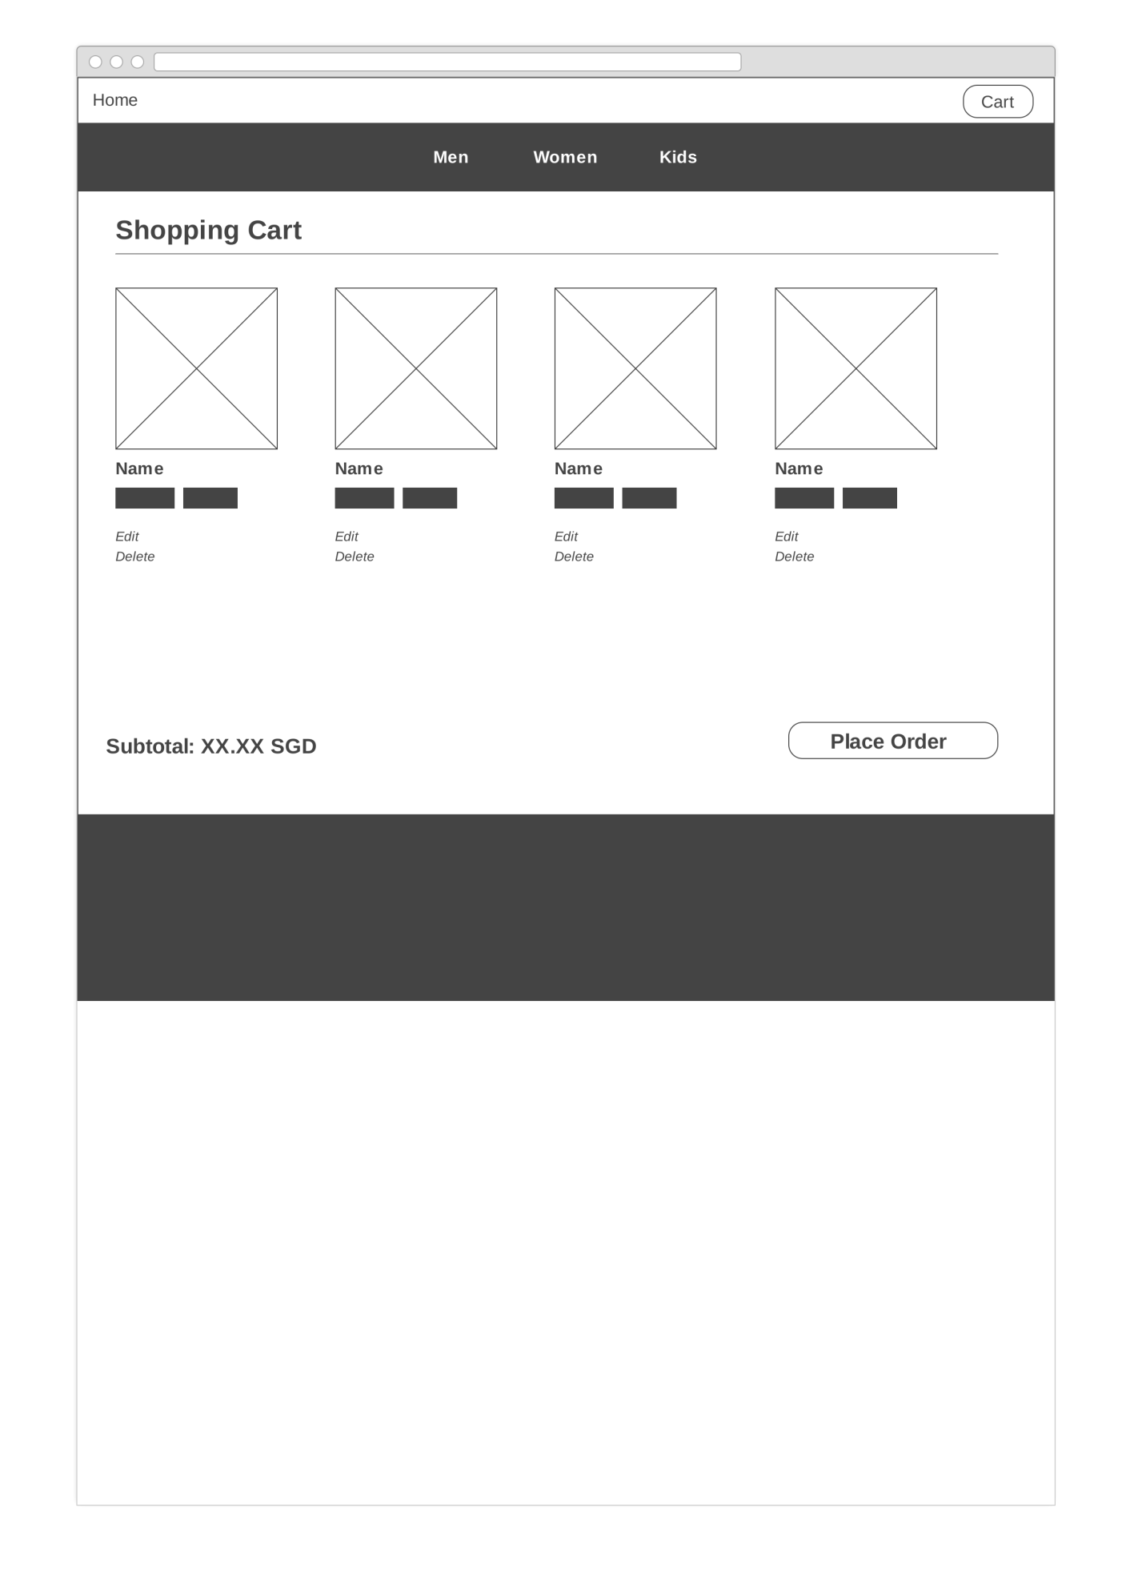

**4. Implementation**

4.1 Coding of the web page template

4.2 Coding of the pages

4.3 Coding of the each function

**5. Testing of web application**

**6. Conclusion**

An online ecommerce portal selling sports shoes is successfully implemented. The web application allows consumers to view and search for products filtered by their preference, add products to shopping cart and place orders. The products are listed with details including images, brand information and choices of styles, sizes etc. Customer can remove/update products in the cart, check out and complete payment easily.

**Appendices**

Appendix : Source Codes

Contribution to the project by each team member shown in a table.